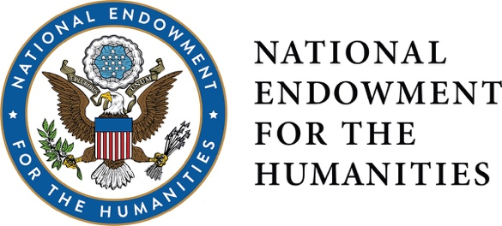
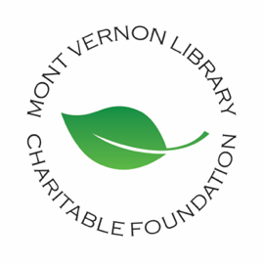
FOR IMMEDIATE RELEASE: April 14, 2022
Mont Vernon Library Charitable Foundation
Media Contact: Cindy Raspiller, 603-673-2667, cindy@mvlcf.org
MONT VERNON LIBRARY PROJECT AWARDED $655,000 GRANT FROM THE NATIONAL ENDOWMENT FOR THE HUMANITIES.
The Infrastructure and Capacity Building Challenge Grant will be used to support construction of a modern, accessible library for the town of Mont Vernon, NH.
Mont Vernon, NH, April 14, 2022 – The Mont Vernon Library Charitable Foundation announced today that it has been awarded a matching grant worth up to $655,000 from the National Endowment for the Humanities. The Infrastructure and Capacity Building Challenge Grant will support building a modern, accessible 7,600 square foot library for the town of Mont Vernon. The new facility will replace the current 1,200 square foot 1909 building, addressing the historic building’s many shortcomings and providing the space, technology, and accessibility to allow library staff and visiting presenters to offer high quality cultural programming for central southern NH residents. A major improvement anticipated by residents is the accessibility of the one-level design. The library is an important gathering space for town residents and the new facility will greatly enhance this important capability.
John Quinlan, Mont Vernon Board of Selectmen Chair, said, “Winning this grant from the National Endowment for the Humanities is a great step forward in our effort to build a library for Mont Vernon’s next one hundred years. The new library will be the centerpiece of our ongoing efforts to revitalize our village center.” Mont Vernon Library Charitable Foundation President, Cindy Raspiller, commented, “This award is a significant boost to our ongoing library capital campaign and will allow us to make the dream of a new Daland Memorial Library a reality sooner.”

NEH announced 23 Infrastructure and Capacity Building Challenge Grants, totaling $11 million. These grants leverage federal funding to strengthen and sustain humanities infrastructure and capacity-building activities at cultural institutions. NEH Chair Shelly C. Lowe (Navajo) said, “NEH is proud to support these exemplary education, media, preservation, research, and infrastructure projects.”

To see the NEH press release and the full list of grantees visit: https://www.neh.gov/news/neh-announces-3317-million-245-humanities-projects-nationwide

https://www.neh.gov/sites/default/files/inline-files/NEH%20grant%20awards%20April%202022%20state%20by%20state%20.pdf

###
Mont Vernon Library Charitable Foundation
Formed in 2015, MVLCF is a nonprofit, volunteer organization dedicated to raising and managing funds for the enhancement and capital improvement of the public library of Mont Vernon, New Hampshire. For more information or to donate, visit https://www.mvlcf.org.
The National Endowment for the Humanities
Created in 1965 as an independent federal agency, the National Endowment for the Humanities supports research and learning in history, literature, philosophy, and other areas of the humanities by funding selected, peer-reviewed proposals from around the nation. Additional information about the National Endowment for the Humanities and its grant programs is available at: www.neh.gov.
Renderings: https://www.mvlcf.org/faqs/#renderings

